JBoss Slimming and Creating a Custom JBoss Configuration

Version 1.0
Date 01/11/10

Copyright notice
Copyright © 2010, Cognizione consulting & solutions Pvt Ltd
All rights reserved.

These materials are confidential and proprietary to Cognizione consulting & solutions pvt
ltd/its licensors and no part of these materials should be reproduced, published, transmitted
or distributed in any form or by any means, electronic, mechanical, photocopying, recording or
otherwise, or stored in any information storage or retrieval system of any nature nor should the
materials be disclosed to third parties without the prior express written authorization of
Cognizione consulting & solutions Pvt ltd/its licensors
Revision history

Doc No: | Version no. | Change reference no. | Author | Published date | Sections changed | Description of changes
 |  |  |  |  |  | Base Document

CONTENTS

Purpose of the document 4

Scope of the document 4

Desired outcome 4

Targeted recipient 4

Prerequisite 4

Required Software 4

Need to Slim down JBoss AS 5

Removing unneeded services 5

Purpose of the document

To demonstrate the following

- How to remove unwanted services from JBoss Application Server (AS) also known as slimming the server.

Scope of the document

This document is all about how to remove unwanted services from JBoss AS so to make it lightweight. It doesn’t cover the following points.

- Installation and configuration of JBoss.
- Operating JBoss Application Server.
- Installation of JBoss service under Linux or other operating systems

Desired outcome

It is expected that after going through this document the reader will be proficient in the following

- Removing unwanted services from JBoss.

Targeted recipient

- Developers working with JBoss AS.
- Implementers who will be responsible for installing JBoss at Client side.

Prerequisite

- Knowledge of JBoss AS.
- Ability to run web applications under JBoss.

Required Software

Following Softwares are required for this tutorial

- JBoss AS 5.0.1 ( downloadable from http://www.jboss.org/jbossas/downloads.html ).

Need to Slim down JBoss AS

Modularity is one of the greatest features of the JBoss AS architecture. You can pick and choose which components you require, and build a configuration containing those pieces.

The main reasons for removing the unwanted services are as follows

- Security - If an unneeded service opens a port, one more entry point is available to a hacker.

- Performance - Services take up memory and processor time. Every service is deployed and initialized, slowing down the boot process and allocating objects, some of which aren’t deallocated until the server is shut down.

- Additionally, some services occasionally wake up to perform periodic tasks, taking processor time away from deployed applications.

Removing unneeded services

The table given below (table1) lists various services that you can remove by deleting files and directories from the server/xxx/deploy and server/xxx/lib directories where “xxx” denotes a server configuration like default, all, web etc.

E.g. if the JBoss server is installed in “D:” folder the server directory will be as shown in the below figure

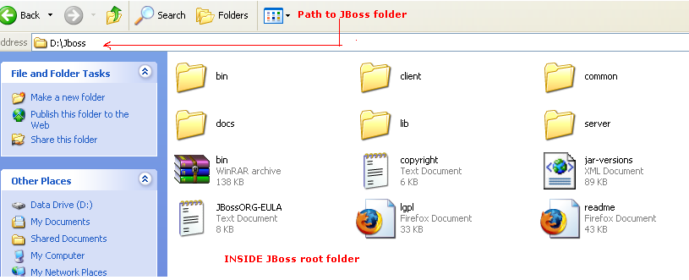
Figure 1 : JBoss directory structure

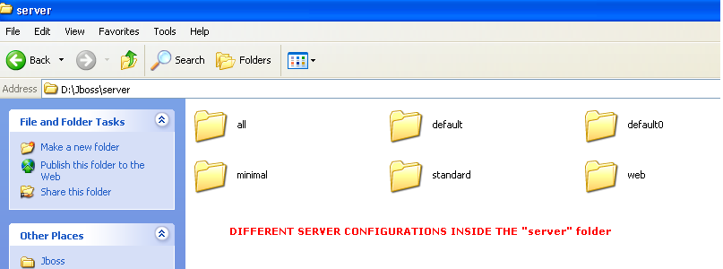

Figure 2 : Inside JBoss server folder showing different server configurations

Table 1 : Services to be removed
